**DAILY ONLINE ACTIVITIES SUMMARY**

|  |  |  |  |  |  |  |  |  |
| --- | --- | --- | --- | --- | --- | --- | --- | --- |
| **Date:** | **04/07/2020** | | | | | **Name:** | **NAIPUNYA VINOD NAIK** | |
| **Sem & Sec** | **IV SEM & A SECTION** | | | | | **USN:** | **4AL18CS050** | |
| **Online Test Summary** | | | | | | | | |
| **Subject** | | **NO INTERNALS CONDUCTED** | | | | | | |
| **Max. Marks** | | **-----------------** | | **Score** | | | **-----------------** | |
| **Certification Course Summary** | | | | | | | | |
| **Course** | **1)** THE EXPERT’S SECRET TO MOBILE APPLICATION TESTING  **2)** DEVOPS FUNDAMENTALS  **3) WEBINAR ON ADVANCE IT AND REQUIREMENTS FOR FUTURE ENGINEERS** | | | | | | | |
| **Certificate Provider** | | | **1) UDEMY**  **2) UDEMY**  **3) AIET** | | **Duration** | | | **1) 1HR**  **2) 2 HRS**  **3) 1 HR** |
| **Coding Challenges** | | | | | | | | |
| **Problem Statement: 1)** [Given an array of integer arr[] and an integer k, the task is to find the median of each window of size k starting from the left and moving towards the right by one position each time.](https://github.com/orgs/alvas-education-foundation/teams/2nd-year/discussions/145) | | | | | | | | |
| **Status: EXECUTED** | | | | | | | | |
| **Uploaded the report in Github** | | | | | **YES** | | | |
| **If yes Repository name** | | | | | <https://github.com/naipunya-naik/lockdown-coding/blob/master/JAVA%20CODING/median_04-07-2020.java> | | | |
| **Uploaded the report in slack** | | | | | **YES** | | | |

Online Test Details: (Attach the snapshot and briefly write the report for the same).

NO INTERNALS CONDUCTED

Certification Course Details: (Attach the snapshot and briefly write the report for the same).

CERTIFICATION COURSE NAME:- THE EXPERT’S SECRET TO MOBILE APPLICATION TESTING

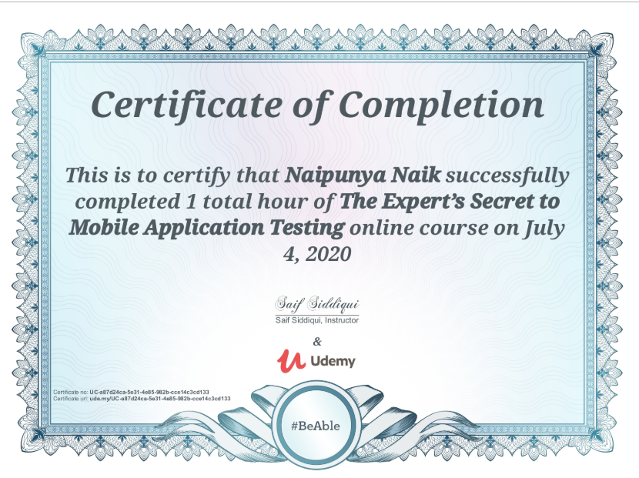

TOPICS COVERED ON 4 JUNE 2020:-

* **How mobile apps work and methodologies including SDLC and STLC**
* **How to test your mobile apps manually**
* **Mobile Application Testing Training – Introduction to mobile device testing**
* **Different terminology used in Mobile App Testing**
* **Real Devices vs Emulators vs Simulators**
* **Different types of Mobile Apps**
* **Common strategy to test all these apps**
* **Test Cases attributes: Software Testing basic**
* **Writing test cases for real mobile app Android and iOS**
* **Bug's attributes: Software Testing basic**
* **Writing a bug report for real mobile app Android and iOS**
* **Mobile Specific Testing**
* **App Managers and Beta tools**
* **Introduction to Firebase**
* **Advance Mobile Concepts like creating iOS, Android Simulators, and ADB commands**
* **Mobile Application Testing Interview Preparation**

2)CERTIFICATION COURSE NAME:- DEVOPS FUNDAMENTALS

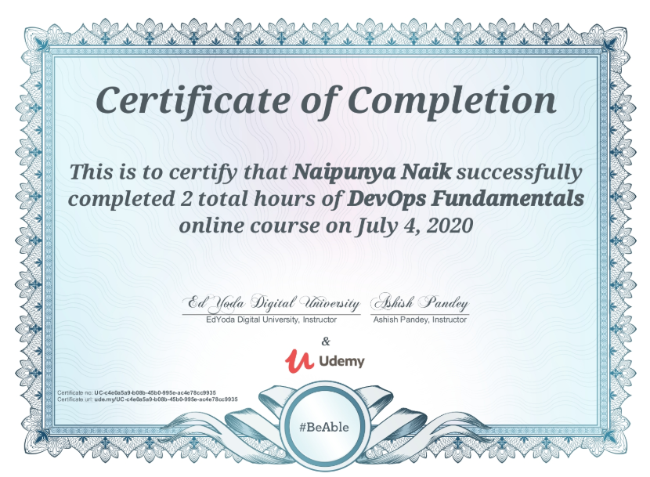

* Learnt what is DevOps and why it is becoming popular in IT industry
* Learnt the fundamental principles of DevOps
* Understand what is a DevOps pipeline
* Learnt how to use the CI/CD tool - Jenkins
* Learnt to use source code management tool - Git

3) GIRLSCRIPT UDUPI

TODAY, I RECEIVED A CERTIFICATE ON GIRLSCRIPT UDUPI FOR ATTENDING WEBINAR INTERNET OF THINGS AND CONNECTED DEVICES.

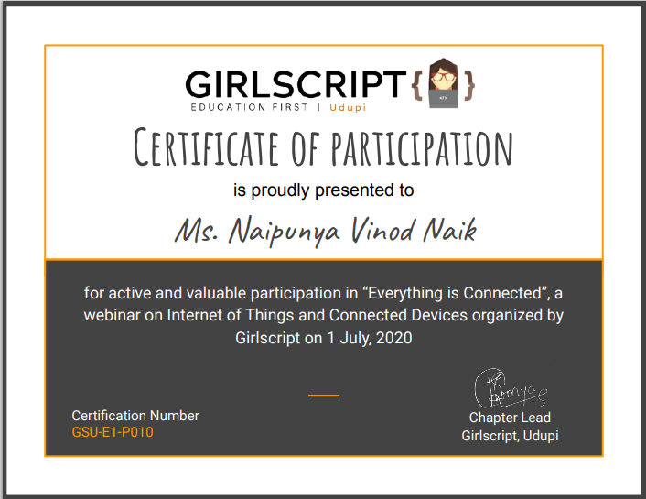

4) WEBINAR ON **ADVANCE IT AND REQUIREMENTS FOR FUTURE ENGINEERS**

* CONDUCTED BY:- ADITYA M. NAIK
* DURATION:-1 HR
* FROM 10 AM TO 11 AM

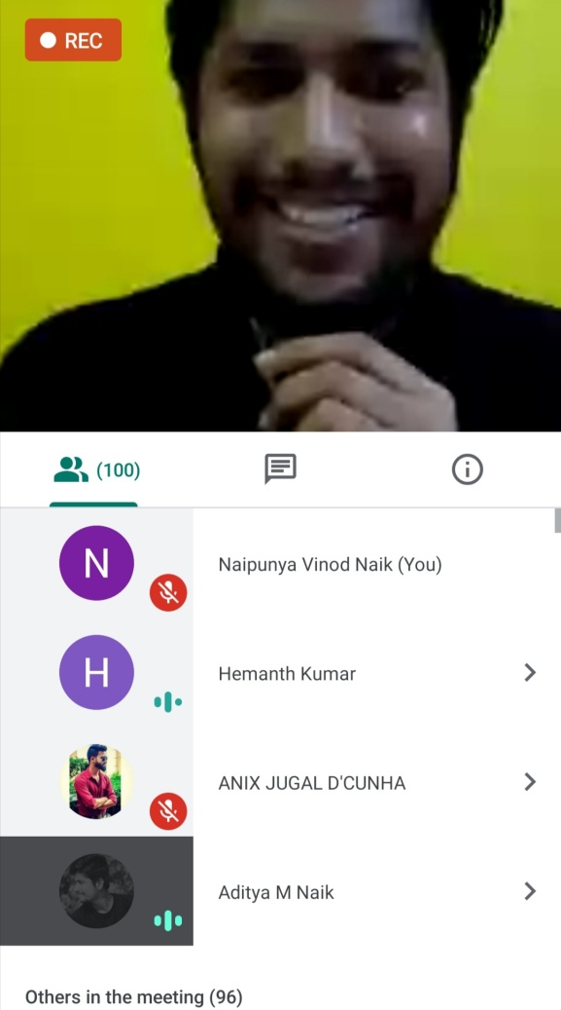 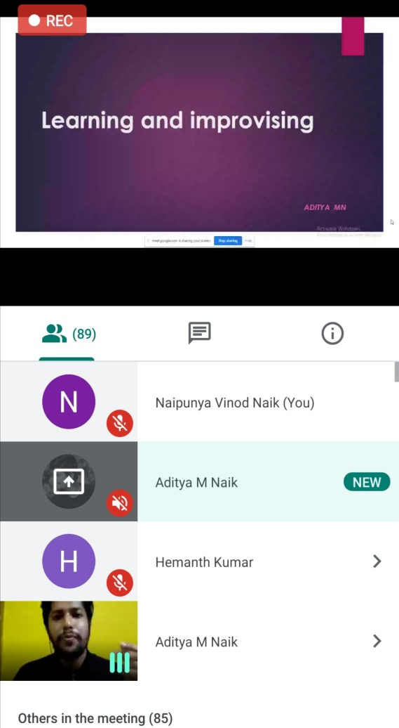

Coding Challenges Details: (Attach the snapshot and briefly write the report for the same).

PROBLEM STATEMENT:- [Given an array of integer arr[] and an integer k, the task is to find the median of each window of size k starting from the left and moving towards the right by one position each time.](https://github.com/orgs/alvas-education-foundation/teams/2nd-year/discussions/145)

Top of Form

Bottom of Form

|  |
| --- |
| Examples: Input: arr[] = {-1, 5, 13, 8, 2, 3, 3, 1}, k = 3 Output: 5 8 8 3 3 3 Input: arr[] = {-1, 5, 13, 8, 2, 3, 3, 1}, k = 4 Output: 6.5 6.5 5.5 3.0 2.5  Screenshot (215).png |

GITHUB REPOSITORY LINK:-

<https://github.com/naipunya-naik/lockdown-coding/blob/master/JAVA%20CODING/median_04-07-2020.java>